Part 1: OpenAI API Key

Part 1: OpenAI API Key
Hey learners,
Hope you’re doing well!
As part of your Applied Agentic AI course, you will be working with Open AI API key. You should receive an API key in your email registered on Interview Kickstart's Uplevel after receiving this communication.
**Please refrain from consuming your API key credits unnecessarily on other projects or work, as we have limited access to these credits during the course. We need these credits for you to use them for the projects completed in the live class and for solving the assignments in this course. **
For now, simply check whether the key is working by following these steps. You can do this small step before the class, so that you are all set

OpenAI API Key and Testing the Key {NEEDED FOR CLASS 1}
You will receive a dedicated OpenAI API Key from Interview Kickstart at your registered email id. That key is going to be used throughout the program, so make sure you save it.
✅ Before the session, make sure your API Key is working.
Use the link below to test your API Key.
→ ⁠https://trevorfox.com/api-key-tester/openai
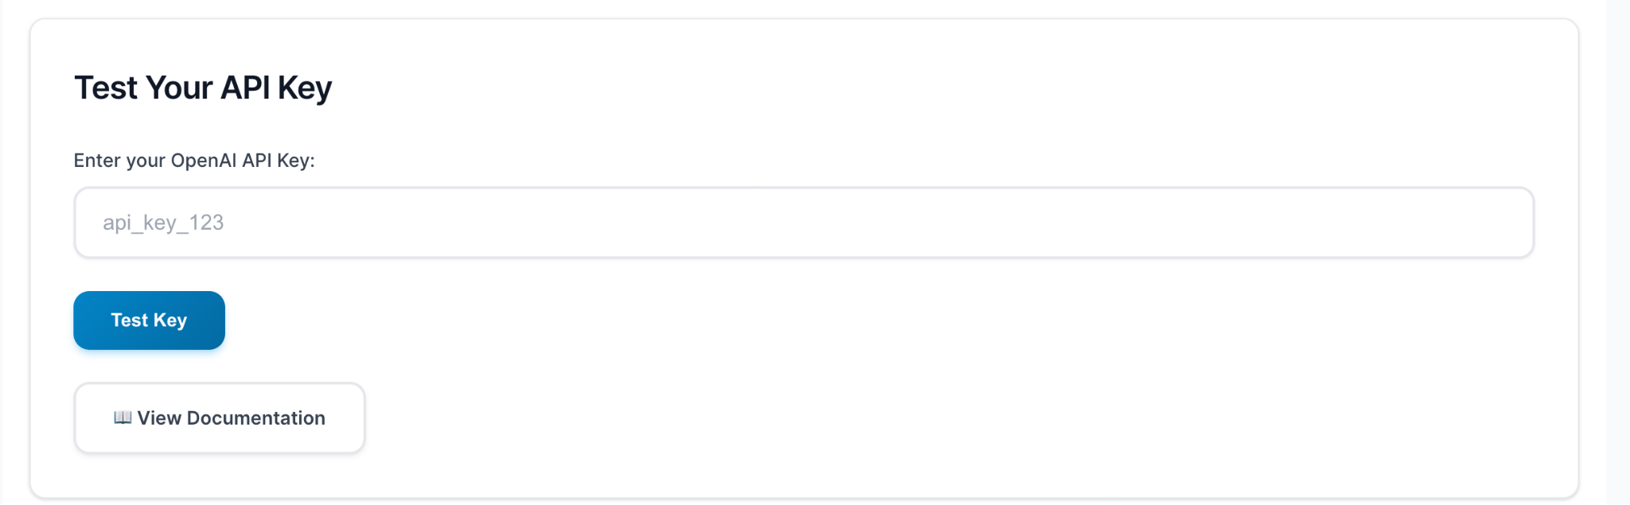

Note: We have shared the OpenAI API key via email. Please check your inbox or spam folder to find it. If you’re unable to locate it, please reply to this email. The API key provides access to the "gpt-4o" model for use during the Week 1 class.

Part 2: Zapier Account Setup

Part 2: Zapier Account Setup
We will be using Zapier for a limited period, so the free tier will be sufficient.Just go through the following steps to set up the account and keep it ready before the class.

It should not take more than 10 minutes.
- Go to: https://zapier.com
- Click on: Start free with Google
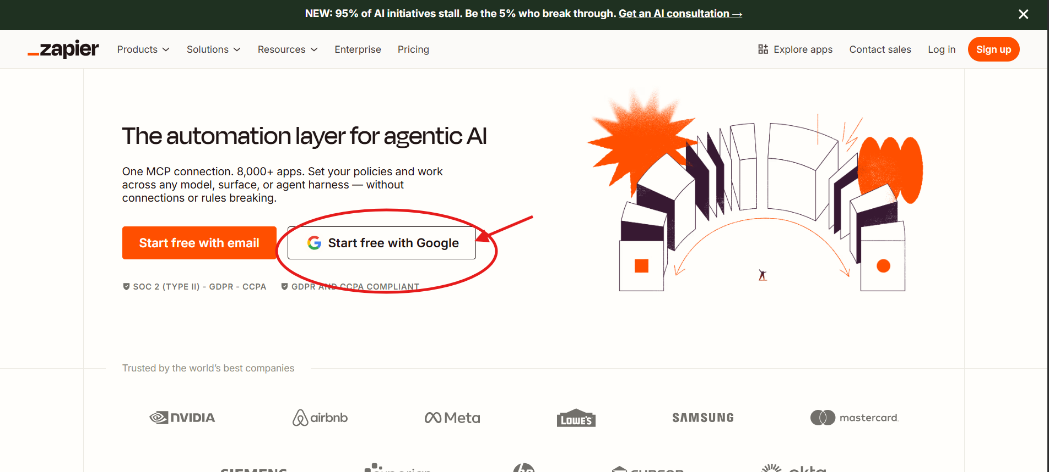
🎉 You’re all set!

You now have access to the Zapier playground.

Note: Please wait until the class begins — the instructor will guide you through the platform, after which you can start building your agents.

**For the Open AI API key received, keep the key handy, while building the agent, you will need this key for the API credentials, the instructor will guide you through on using them.

